Notes: Print 1 on dark grey or black paper for the rain cloud and 1 on white paper for the partly cloudy cloud.



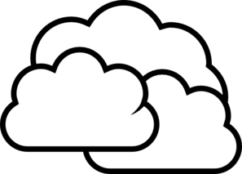

Notes: Print 1 on white or light grey paper for cloudy.

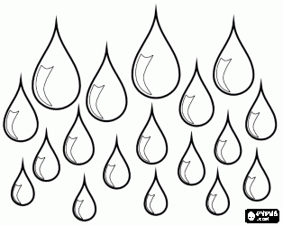

Notes: Print on blue paper and then cut out and hang from cloud with thread or string.

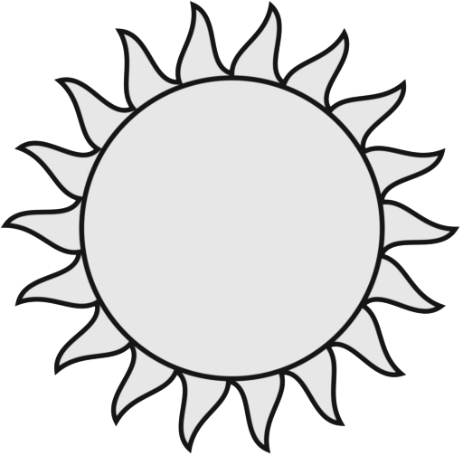

Notes: Print 2 on yellow paper. Paste 1 behind the cloud for partly cloudy and use 1 for sunny.

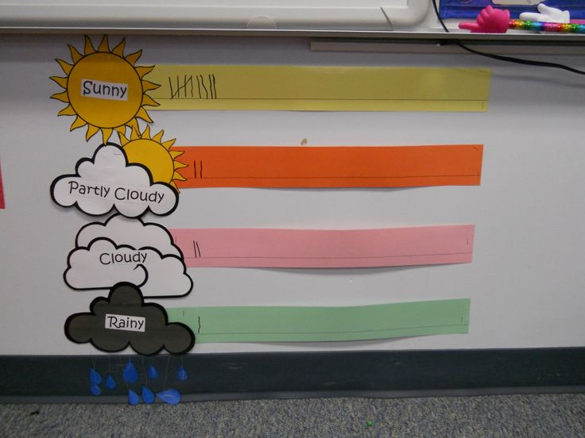Sunny

Notes: Print on white paper and then paste on each weather

Partly Cloudy

Cloudy

Rainy