Race to $1. 00
Students Expectations:
- 2.5A Determine the value of a collection of coins up to one dollar.
- 2. 5B Use the cent symbol, dollar sign, and decimal point to name the value of a collection of coins.

Teacher Directions:
- Decide which dice you are going to use (money words, money pictures, or regular dice.) If using the money words or money picture dice then copy on card stock, laminate, fold, and tape together.
- If using a regular dice then copy the dice/money correlation sheet and laminate for sturdiness (Should have 1 dice per student)
- Copy the hundreds chart and recording sheet on cardstock and laminate or copy on regular paper to be written on.
- Provide either coins or a small object for the students to move on the chart.

Student Directions:
1. Place your piece on the starting spot.
2. Roll the dice.
3. Move your piece the number of squares that equal the value of the coin or coins on the dice.
4. Record what coins you rolled and your new total on the sheet.
5. The first player to reach the $1.00 wins.

1₵ | 2₵ | 3₵ | 4₵ | 5₵ | 6₵ | 7₵ | 8₵ | 9₵ | 10₵
11₵ | 12₵ | 13₵ | 14₵ | 15₵ | 16₵ | 17₵ | 18₵ | 19₵ | 20₵
21₵ | 22₵ | 23₵ | 24₵ | 25₵ | 26₵ | 27₵ | 28₵ | 29₵ | 30₵
31₵ | 32₵ | 33₵ | 34₵ | 35₵ | 36₵ | 37₵ | 38₵ | 39₵ | 40₵
41₵ | 42₵ | 43₵ | 44₵ | 45₵ | 46₵ | 47₵ | 48₵ | 49₵ | 50₵
51₵ | 52₵ | 53₵ | 54₵ | 55₵ | 56₵ | 57₵ | 58₵ | 59₵ | 60₵
61₵ | 62₵ | 63₵ | 64₵ | 65₵ | 66₵ | 67₵ | 68₵ | 69₵ | 70₵
71₵ | 72₵ | 73₵ | 74₵ | 75₵ | 76₵ | 77₵ | 78₵ | 79₵ | 80₵
81₵ | 82₵ | 83₵ | 84₵ | 85₵ | 86₵ | 87₵ | 88₵ | 89₵ | 90₵
91₵ | 92₵ | 93₵ | 94₵ | 95₵ | 96₵ | 97₵ | 98₵ | 99₵ | $1.00
Race to $1.00
FINISH!

START!

 |  |  | GLUE/TAPE
 |  | GLUE/TAPE | PENNY | GLUE/TAPE
GLUE/TAPE | DIME |  | NICKEL |  | QUARTER | GLUE/TAPE
 |  | GLUE/TAPE | PENNY | GLUE/TAPE
 |  |  | 3 NICKELS
 |  |  | GLUE/TAPE
 |  | GLUE/TAPE | NICKEL | GLUE/TAPE
GLUE/TAPE | DIME |  | 2 NICKELS |  | QUARTER | GLUE/TAPE
 |  | GLUE/TAPE | 2 DIMES | GLUE/TAPE
 |  |  | 3 NICKELS
 |  |  | GLUE/TAPE
 |  | GLUE/TAPE | PENNY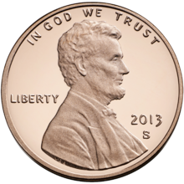 | GLUE  /TAPE
GLUE/TAPE | DIME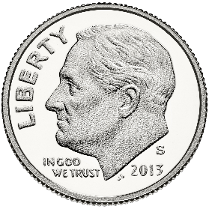 |  | NICKEL |  | QUARTER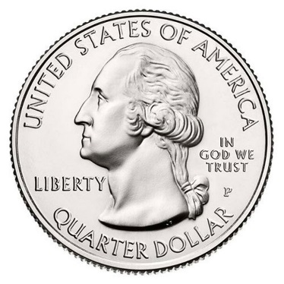 | GLUE/TAPE
 |  | GLUE/TAPE | PENNY | GLUE/TAPE
 |  |  | 2 NICKELS

 |  |  | GLUE/TAPE
 |  | GLUE/TAPE | NICKEL | GLUE  /TAPE
GLUE/TAPE | DIME |  | 2 NICKELS |  | QUARTER | GLUE/TAPE
 |  | GLUE/TAPE | 2 DIMES  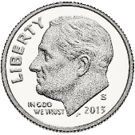 | GLUE/TAPE
 |  |  | 3 NICKELS

Race to $1. 00
= nickel
= 2 nickels
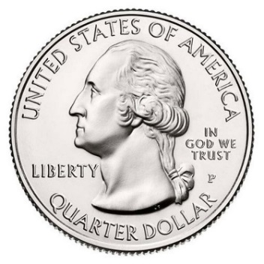
= dime
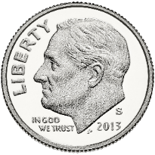
= quarter
= 2 dimes
= 3 nickels

Race to $1. 00
= penny
= nickel
= dime
= quarter
= penny
= 2 nickels
Race to $1. 00
Turn | New Coin(s) | Total Amount ₵ | Total Amount $_.__
1
2
3
4
5
6
7
8
9
10

Race to $1. 00
Turn | New Coin(s) | Total Amount
1
2
3
4
5
6
7
8
9
10

